IcoMap for ArcGIS Use Case Model

Introduction

The purpose of this use case document is to describe completely all the ways that customers will use the IcoMap for ArcGIS product. It specifies the essential requirements for the initial IcoMap for ArcGIS product release. In effect, it is a paper prototype that helps us to develop the product that best meets the needs of our customers while at the same time best managing our development risks. Once the essential features have been agreed upon, this use case model will guide the development of the software design, the software test plan and the user documentation.

The first release of the IcoMap for ArcGIS product shall deliver only those features essential to penetrate the ESRI marketplace rapidly. The product’s value proposition is to enable a customer to quickly and accurately draw an ArcGIS map based upon an existing legal title or map. UCLID Software will develop the IcoMap for ArcGIS product as a plug-in component for Environmental Systems Research Institute’s ArcGIS version 8. See Appendix A for an overview of the ArcGIS version 8 product line. See User Interface Figure 1 for an example of the pull-down menu and toolbar that IcoMap for ArcGIS adds to the ArcMap user interface.

Actors
An actor represents a role that a person or another computer system plays while interacting with the IcoMap for ArcGIS system. A user can play the role of several actors. For example, a surveyor that uses the software could play the role of Cartographer, Analyst and Surveyor at different times. Each interaction an actor has with the system is captured in a separate use case.

Administrator
The role of Administrator designates the user responsible for installing and setting up the IcoMap for ArcGIS software.

Cartographer (i.e. mapper)
The role of Cartographer designates the user that draws the maps. This will most likely be the primary user of the software. See Appendix B.

Analyst
The role of Analyst designates the user that checks the accuracy and quality of the drawings.

System
The role of System designates the IcoMap for ArcGIS software itself.

Surveyor
The role of Surveyor designates the individual who most likely created the original source information.

Document conventions
- Words between single quotes indicate a ‘Dialog’, ‘Button’, ‘Menu item’, ‘Command’ or ‘Control’.
- Words in italics indicate an Actor or another Use Case.
- Sometimes a use case includes another use case. The included use case is identified by the <<Include>> stereotype and depicted by a dotted line on a use case diagram.



User Interface Figure 1 – IcoMap Toolbar

Cartographer Use Cases

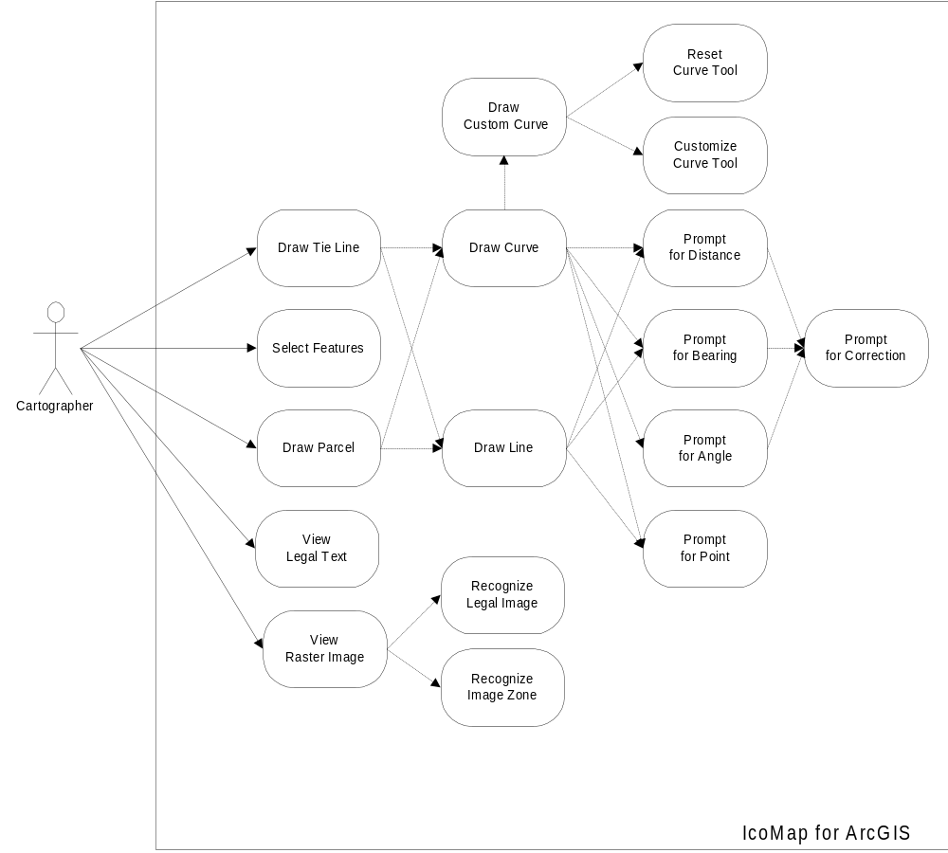

Use Case Diagram 1 – Primary Use Cases for Cartographer

Draw Parcel
Intention
The Cartographer wants to draw a parcel.

Pre-condition
The ‘IcoMap’ dialog box must be displayed. The polygon or line layer must currently be selected. The Cartographer must not currently be drawing a sketch.

Notes
The line and curve tools will not work if a points layer is selected. It is also bad if the user changes layers in the middle of a sketch. See User Interface Figure 1.

  - This use case begins when the Cartographer clicks a drawing button.
  - The System prompts the Cartographer for a starting point using the Prompt for Point use case.
  - The Cartographer draws a line using the Draw Line use case. This repeats until the Cartographer changes the drawing tool or finishes the sketch.
Variant:
- The Cartographer draws a curve using the Draw Curve use case. This repeats until the Cartographer changes the drawing tool or finishes the sketch.
  - The Cartographer clicks the ‘Finish Sketch’ button.
Variant:
- The Cartographer clicks the ‘Finish Part’ button to take them back to step 1.2 using the currently selected tool.
  - This use case ends when the Cartographer clicks the ‘Finish Sketch’.

Draw Tie Line
Intention
The Cartographer wants to draw a tie line.

Pre-condition
The ‘IcoMap’ dialog box must be displayed. The line layer must currently be selected. The Cartographer must not currently be drawing a sketch.

Notes
The line and curve tools will not work if a points layer is selected. It is also bad if the user changes layers in the middle of a sketch. See User Interface Figure 1.

  - This use case begins when the Cartographer selects a drawing tool.
  - The System prompts the Cartographer for a start point using the Prompt for Point use case.
  - The Cartographer draws a line using the Draw Line use case. This repeats until the Cartographer changes the drawing tool or finishes the sketch.
Variant:
- The Cartographer draws a line using the Draw Curve use case. This repeats until the Cartographer changes the drawing tool or finishes the sketch.
  - This use case ends when the Cartographer clicks the ‘Finish Sketch’ button.

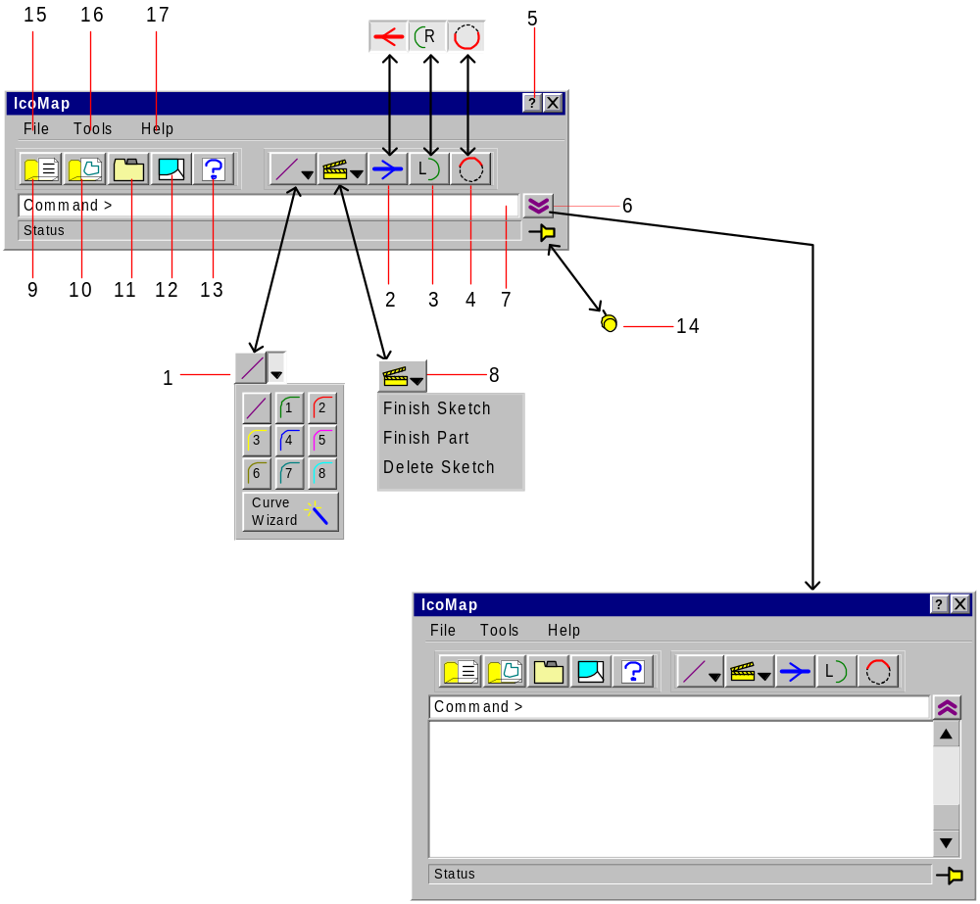

User Interface Figure 2 – IcoMap Dialog

Figure 2 Notes
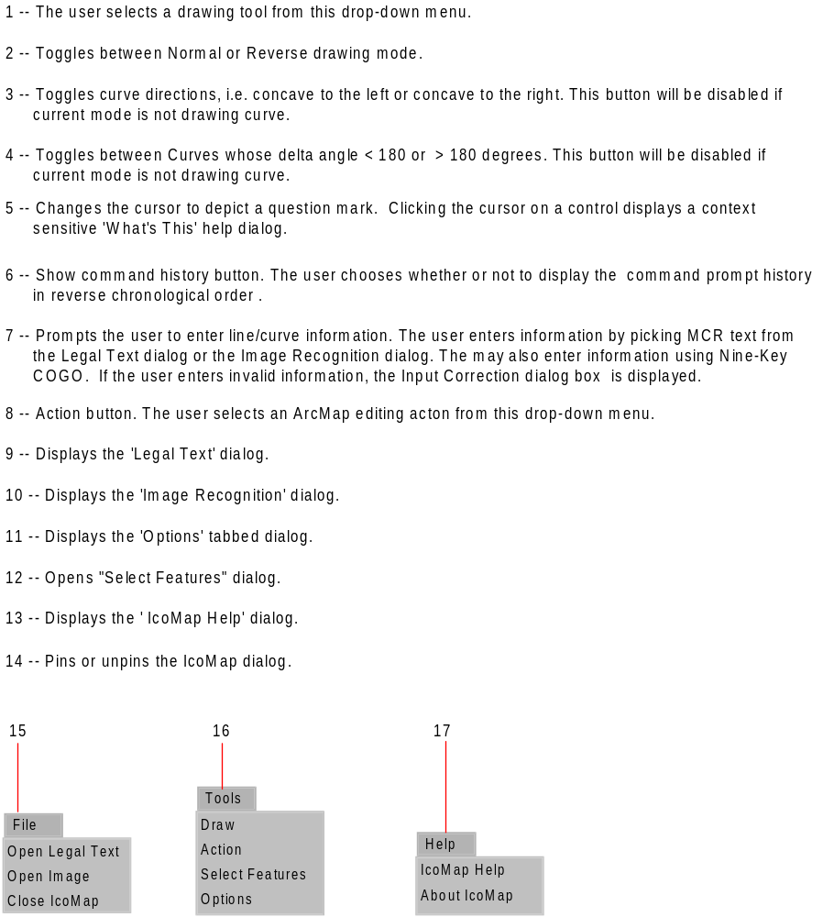

View Legal Text
Intention
The Cartographer wants to open a text document containing mathematical content to use when drawing vector lines.

Pre-condition
The ‘Legal Text’ dialog box must be open.

Post-condition
The System highlights all mathematical content in the ‘Legal Text’ dialog.

Notes
See User Interface Figure 3.

  - This use case begins when the Cartographer clicks the ‘Open’ button on the ‘Legal Text’ dialog.
Variants:
- The Cartographer clicks the ‘Open Text’ button in the ‘IcoMap’ dialog box. The System displays a new ‘Legal Text’ dialog.
- The System prompts the Cartographer to choose a text document to open using a standard ‘Open’ dialog.

  - The Cartographer chooses a text document to open.
Variants:
- The Cartographer closes the ‘Open’ dialog without choosing a text document to open, and this use case ends.
- This use case ends when the System displays the text document in the active ‘Legal Text’ dialog.

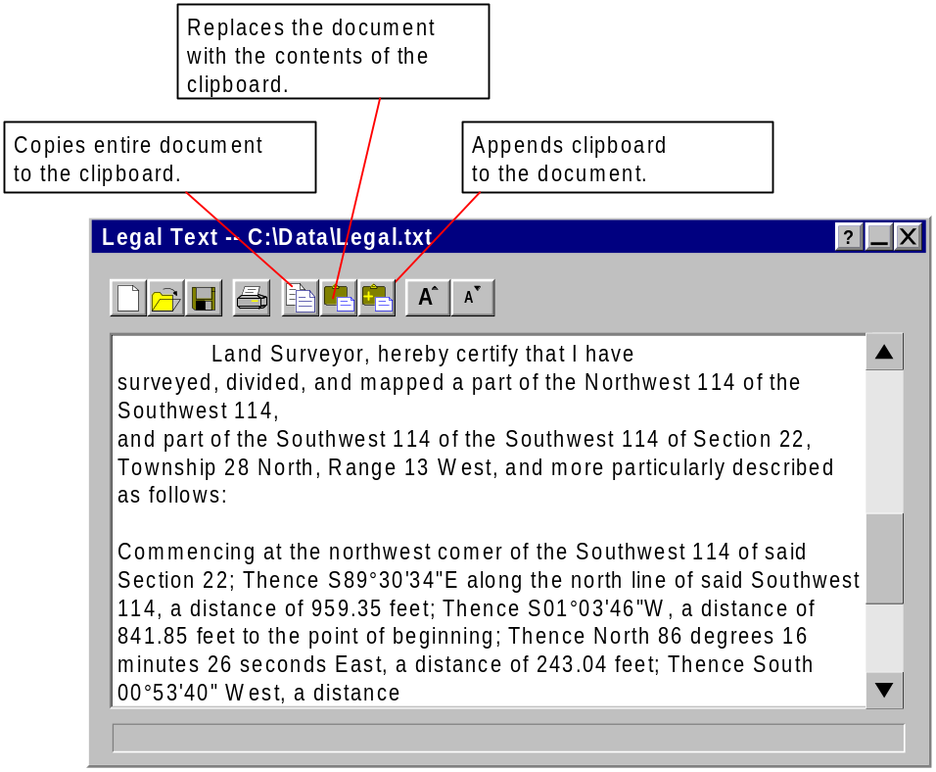

User Interface Figure 3 – Legal Text Dialog

View Raster Image
Intention
The Cartographer wants to open a raster image document containing mathematical content to use when drawing vector lines.

Pre-condition
The ‘Image Recognition’ dialog box must be open.

Notes
See User Interface Figure 4.

  - This use case begins when the Cartographer clicks the ‘Open’ button on the ‘Image Recognition’ dialog.
Variants:
- The Cartographer clicks the ‘Open Image’ button in the ‘IcoMap’ dialog box. The System displays a new ‘Image Recognition’ dialog.
  - The System prompts the Cartographer to choose a raster image document to open using a standard ‘Open’ dialog.
  - The Cartographer chooses a raster image document to open.
Variants:
- The Cartographer closes the ‘Open’ dialog without choosing a raster image document to open, and this use case ends.
  - This use case ends when the System displays the raster image file in the ‘Image Recognition’ dialog.

Recognize a Selected Image Area <<Include>>
Intention
The Cartographer wants to window a portion of an image containing horizontal text to recognize and and output to a legal text dialog box.

Pre-condition
There must be a raster image of a text document open in the ‘Image Recognition’ dialog.
Post-condition
If the Cartographer chooses a pre-existing ‘Legal Text’ dialog box, the recognized text should append to the end of that dialog box.

Notes
See User Interface Figure 4 and 5.

  - This use case begins when the Cartographer clicks the ‘Recognize a window’ button on the ‘Image Recognition’ dialog.
  - The System prompts the user to window an area to recognize.
  - The Cartographer windows the area he/she wants to recognize.
  - The System displays the ‘Choose a Legal Text Dialog Box’ dialog box which contains a list of all of the open Legal Text dialog boxes plus an option for a new dialog box.
  - The Cartographer selects the dialog box he/she wants the text to output to and clicks the ‘OK’ button.
Variant
- The Cartographer clicks the ‘Cancel’ button.
  - This use case ends when the System displays the recognized text in the chosen ‘Legal Text’ dialog per the Cartographer clicking the ‘OK’ button and closes the ‘Choose a Legal Text Dialog Box’ dialog box.
Variant
- This use case ends when the System closes the ‘Choose a Legal Text Dialog Box’ dialog box without recognizing the selected window.

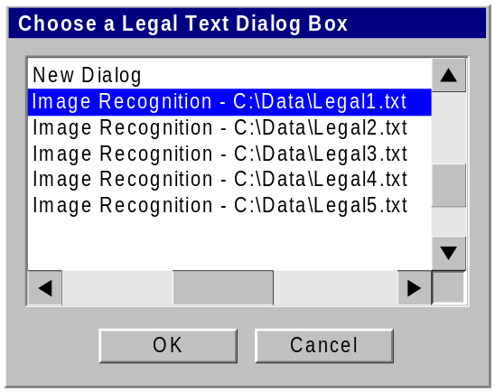
User Interface Figure 4 - Choose a Legal Text Dialog Box

Recognize Image Zone <<Include>>
Intention
The Cartographer wants to convert to text some mathematical content within an image of a parcel map or legal description because they want to draw a vector.

Pre-condition
There must be a raster image open in the ‘Image Recognition’ dialog.

Notes
See User Interface Figure 5.

  - This use case begins when the Cartographer clicks the ‘Zone Recognition’ button on the ‘Image Recognition’ dialog.
  - Using the mouse the Cartographer highlights the mathematical content on the image. Before releasing the left-mouse button, the Cartographer may adjust the height of the highlighted zone by pressing the ‘+’ or ‘-‘ key as appropriate.
  - When the Cartographer releases the left-mouse button, the System performs optical character recognition on the selected zone.
  - This use case ends when the System sends the recognized text as input to the active command.

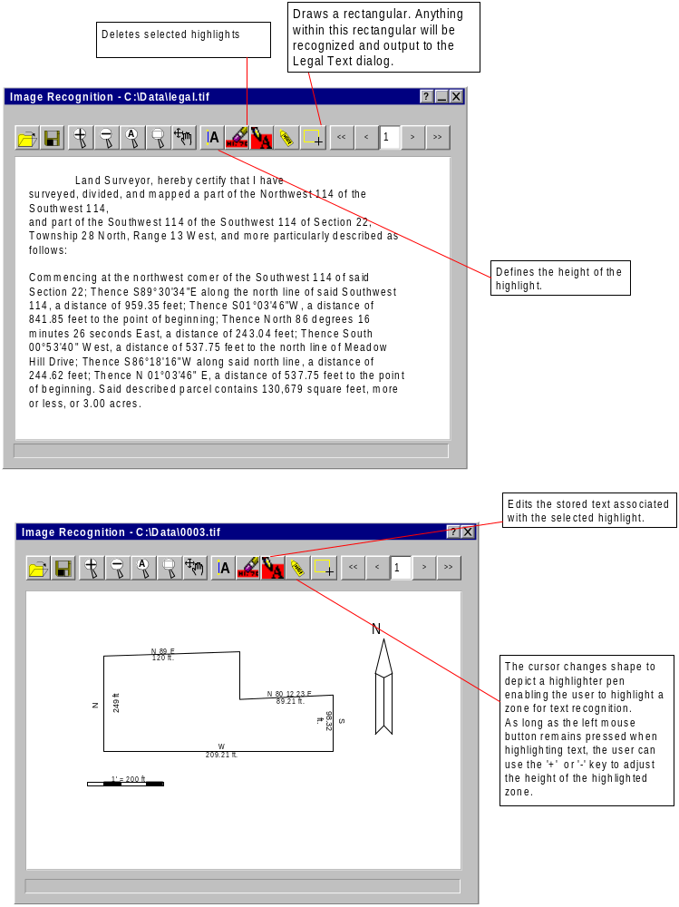

User Interface Figure 5 – Image Recognition Dialog

Select Features with a Common Hyper Link
Intention
The Cartographer wants to select features with a common hyperlink.

Notes
The Cartographer can click the ‘Cancel’ button at any time while the ‘Select Features’ dialog box is open to exit the function.
See User Interface Figure 6.

  - This use case begins when the Cartographer clicks the ‘Select Features’ menu option.
  - The System displays the ‘Select Features’ dialog box.
  - The Cartographer types the hyperlink string in the edit box.
  - The Cartographer clicks the ‘OK’ button.
  - This use case ends when the System selects the features that have the hyper link that the Cartographer typed.

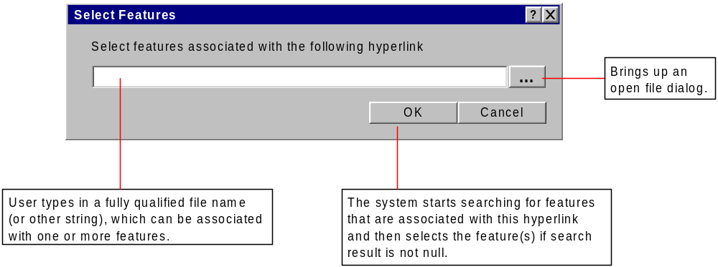
User Interface Figure 6 – Select Features

Draw Line << Include >>
Intention
The Cartographer wants to draw a line by entering 2 pieces of information.

Pre-condition
A starting point must have been selected or a line or curve must have been drawn in the current sketch.

  - This use case begins when the Cartographer clicks the ‘Line’ button.
  - The System uses the endpoint of the previous line or curve within the same sketch for the starting point.
Variant:
- The System uses the starting point the user selected at the beginning of the sketch for the starting point.
  - The System prompts the Cartographer for the bearing using the Prompt for Bearing use case.
  - The System prompts the Cartographer for the distance using the Prompt for Distance use case.
  - The System draws the line.
  - The Cartographer may repeat the use case beginning with step 8.2.
  - This use case ends when the Cartographer clicks a different drawing button or ends the current sketch.

Draw Curve <<Include>>
Intention
The Cartographer wants to draw a curve by entering 3 pieces of information and curve direction.

Pre-condition
A starting point must have been selected or a line or curve must have been drawn in the current sketch.

Notes
See Table 19.

  - This use case begins when the Cartographer clicks a ‘Curve’ button.
  - The System uses the endpoint of the previous line or curve within the same sketch for the starting point.
Variant:
- The System uses the starting point the Cartographer selected at the beginning of the sketch for the starting point.
  - The Cartographer provides the first piece of curve data in response to the System’s prompt.
  - The Cartographer provides the second piece of curve data in response to the System’s prompt.
  - The Cartographer provides the third piece of curve data in response to the System’s prompt.
  - The System draws the curve.
  - The System then prompts the Cartographer to optionally toggle the curve’s direction and delta angle.
  - The Cartographer may toggle the curve’s delta angle by clicking the ‘Delta Angle’ button so that the curve’s delta angle is either greater than or less than 180 degrees as desired.
  - The Cartographer may toggle the curve’s direction by clicking the ‘Curve Concavity’ button so that the curve faces left or right as desired.
Variants:
- The Cartographer toggles the curve concavity by typing either ‘l’ or ‘r’ as appropriate for the desired curve direction.
  - Toggling the curve direction and delta angle ends when the Cartographer presses the ‘Enter’ key.
  - The Cartographer may repeat the use case beginning with step 9.2.
  - This use case ends when the Cartographer clicks a different drawing button or finishes the current part or sketch.

Draw Custom Curve <<Include>>
Intention
The Cartographer wants the System to prompt him for curve information that is not handled by any of the curve buttons.

Notes
See User Interface Figure 7.

  - This use case begins when the Cartographer clicks the ‘Curve Wizard’ button on the ‘IcoMap’ dialog.
  - The System opens the ‘Curve Wizard’ modal dialog. The ‘Save As’ button is disabled.
  - The Cartographer selects from a list the first type of information for which he wants to be prompted.
  - The System tailors the contents of the second list of available prompts according to the Cartographer’s previous selection. The System erases any prior selection in the second and third list boxes.
  - The Cartographer selects from the second list box the type of information for which he wants to be prompted.
  - The System tailors the contents of the third list of available prompts according to the Cartographer’s previous selection. The System erases any prior selection in the third list box.
  - The Cartographer selects from the third list box the type of information for which he wants to be prompted.
  - The System enables the ‘Save As’ button.
  - This use case ends when the Cartographer clicks the ‘Draw’, ‘Close’ or ‘Cancel’ button.
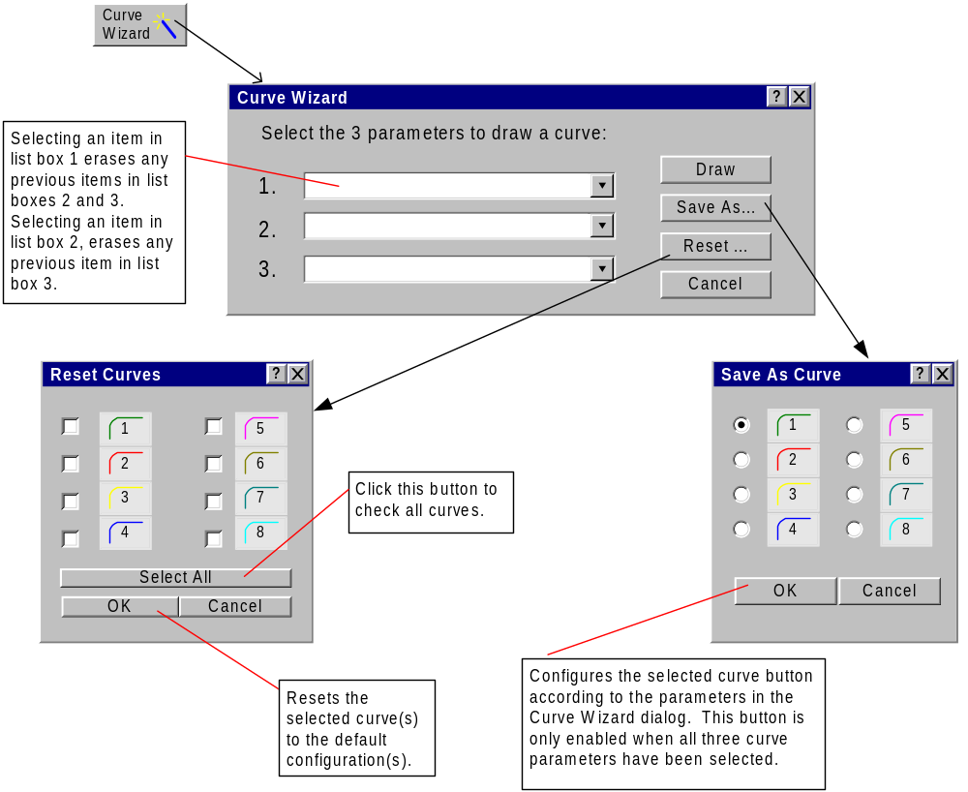
User Interface Figure 7 – Curve Wizard Dialog

Customize Curve Tool << Include >>
Intention
The Cartographer wants to customize the curve information prompts associated with one of the curve tools.

Pre-condition
All three curve information prompts must be selected in the ‘Curve Wizard’ dialog.

  - This use case begins when the Cartographer clicks the ‘Save As’ button on the ‘Curve Wizard’ dialog.
  - The System displays the ‘Save As Curve’ dialog.
  - The Cartographer selects the curve button to which to associate the curve information prompts.
  - This use case ends when the Cartographer clicks either the ‘OK’ or ‘Cancel’ button.

Reset Curve Tool <<Include>>
Intention
The Cartographer wants to reset one or more of the curve tools to the original factory defaults.

Pre-condition
The ‘Curve Wizard’ dialog must be open.

  - This use case begins when the Cartographer clicks the ‘Reset’ button on the ‘Curve Wizard’ dialog.
  - The System displays the ‘Reset Curves’ dialog box.
  - The Cartographer selects one or more curve buttons to reset.
Variant:
- The Cartographer clicks the ‘Select All’ button to select every curve button.
  - This use case ends when the Cartographer clicks the ‘OK’ button to restore the selected curve buttons or clicks the ‘Cancel’ button.

Prompt for Point <<Include>>

Intention
The System requires the Cartographer to select a point.

Pre-condition
A command is active that requires the Cartographer to input a point.

  - This use case begins when the System prompts the Cartographer to select a point.
  - The Cartographer picks a point using the mouse cursor. The Cartographer can use object snaps to accurately select specific a point of another vector entity.
Variant:
- The Cartographer picks a point by entering the X, Y coordinate value.
  - This use case ends after the System returns the X, Y coordinate location to the command requesting this input.

Prompt for Distance <<Include>>
Intention
The System requires the Cartographer to enter a distance.

Pre-condition
A command is active that requires the Cartographer to input a distance.

  - This use case begins when the System prompts the Cartographer to input a distance.
  - The Cartographer picks a distance highlighted by MCR from within the ‘Legal Text’ dialog.
Variant:
- The Cartographer picks a distance by highlighting a section of a raster containing distance text using the Recognize Image Zone use case.
- The Cartographer types a distance using COGO.
- The Cartographer picks a distance by clicking on a highlight that already exists.
  - The System evaluates the distance using the Distance Interpretation Requirements and prompts the Cartographer to correct the input using the Prompt for Correction use case if the distance value is invalid.
  - This use case ends when the Cartographer enters a valid distance value or cancels the command.

Prompt for Bearing <<Include>>
Intention
The System requires the Cartographer to enter a bearing.

Pre-condition
A command is active that requires the Cartographer to input a bearing.

  - This use case begins when the System prompts the Cartographer to select a bearing.
  - The Cartographer picks a bearing highlighted by MCR from within the ‘Legal Text’ dialog.
Variant:
- The Cartographer picks a bearing by highlighting a section of a raster containing bearing text using the Recognize Image Zone use case.
- The Cartographer types a bearing using COGO.
- The Cartographer picks a bearing by clicking on a highlight that already exists.
  - The System evaluates the bearing using the Bearing Interpretation Requirements and prompts the Cartographer to correct the input using the Prompt for Correction use case if the bearing value is invalid.
  - This use case ends when the Cartographer enters a valid bearing value or cancels the command.

Prompt for Angle <<Include>>
Intention
The System requires the Cartographer to enter an angle.

Pre-condition
A command is active that requires the Cartographer to input an angle.

  - This use case begins when the System prompts the Cartographer to select an angle.
  - The Cartographer picks an angle highlighted by MCR from within the ‘Legal Text’ dialog.
Variant:
- The Cartographer picks an angle by highlighting a section of a raster containing angle text using the Recognize Image Zone use case.
- The Cartographer types an angle using COGO.
- The Cartographer picks an angle by clicking on a highlight that already exists
  - The System evaluates the angle using the Angle Interpretation Requirements and prompts the Cartographer to correct the input using the Prompt for Correction use case if the angle value is invalid.
  - This use case ends when the Cartographer enters a valid angle value or cancels the command.

Prompt for Correction <<Include>>
Intention
The System requires the Cartographer to correct an input value.

Pre-condition
The System has detected an invalid value.
Post-condition
If the Cartographer cancels the ‘IcoMap Input Correction’ dialog box, the highlight that was defined for the invalid text automatically gets deleted.

Notes
See User Interface Figure 8.

  - This use case begins when the Cartographer enters an invalid value and needs to correct it.
  - The System displays the ‘Input Correction’ dialog. This dialog includes a method for editing the value the Cartographer entered and a list of alternatives using the Value Alternative Requirements.
Variant:
- The System gives a list of alternatives using the Bearing Alternative Requirements.
- The System gives a list of alternatives using the Angle Alternative Requirements.
  - The Cartographer corrects the invalid value.
  - This use case ends when the Cartographer enters a valid value or cancels the command.

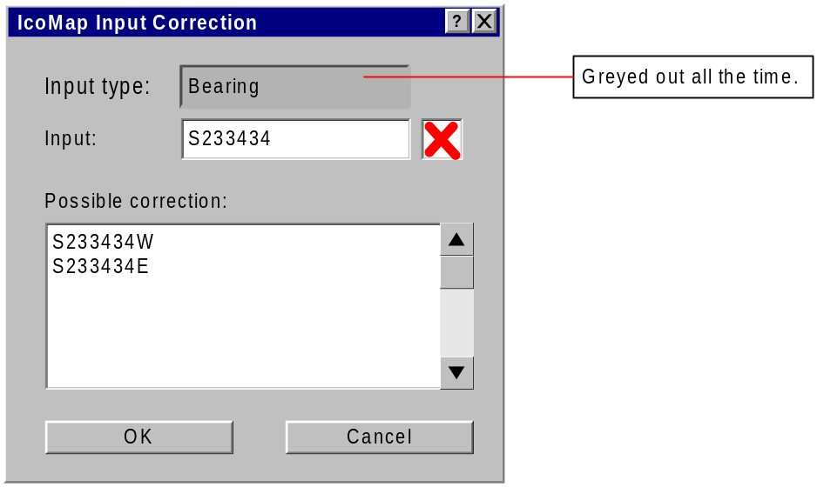
User Interface Figure 8 – Curve Wizard Dialog

Save Image Highlights
Intention
The Cartographer wants to save the highlights that were used to recognize the image.

Pre-condition
The ‘Image Recognition’ dialog box must be active. One or more highlights must exist for the image.

Notes
The file that stores the location of the highlights is called a .gdd file.

  - This use case begins when the Cartographer clicks the ‘Save’ button on the ‘Image Recognition’ dialog box.
  - The System displays the ‘Save’ dialog box with the default directory location being the same location as the image and the file name will default to imagename.gdd .
Variant
- The System displays the ‘Save’ dialog box with the default directory location being the last location the Cartographer saved a .gdd file.
- If the .gdd file has already been saved, the System will save the .gdd file in the same location without prompting the Cartographer.
  - The Cartographer clicks the ‘Save’ button to save the .gdd file in the default location.
Variant
- The Cartographer chooses a different name and/or location for the .gdd file and clicks the ‘Save’ button.
- The Cartographer clicks the ‘Cancel’ button.
  - This use case ends when the System saves the .gdd file and closes the ‘Save’ dialog box per the Cartographer clicking the ‘Save’ button.
Variant
- This use case ends when the System closes the ‘Save’ dialog box without saving per the Cartographer clicking the ‘Cancel’ button.

Open Highlights
Intention
The Cartographer wants to open the image and the highlights that were used to recognize the image.

Pre-condition
The ‘Image Recognition’ dialog box must be active.

  - This use case begins when the Cartographer clicks the ‘Open’ button in the ‘Image Recognition’ dialog box.
  - The System displays an ‘Open’ dialog box which defaults to the last directory location the Cartographer opened an image or .gdd file from.
  - The Cartographer Selects a .gdd file to open.
  - This use case ends when the System opens the .gdd file and the image associated to it.

Edit Highlights
Intention
The Cartographer wants to modify or view the text recognized by the highlights.

Pre-condition
The ‘Image Recognition’ dialog box must be active. One or more highlights must exist for the image.
Notes
See User Interface Figure 9

  - This use case begins when the Cartographer clicks the ‘Edit Highlights’ button in the ‘Image Recognition’ dialog box.
  - The System prompts the user to select a highlight.
  - The Cartographer moves his/her mouse cursor over one of the highlights and presses the left mouse button.
  - The System displays the ‘Edit Highlights’ dialog box with the text stored for that highlight in the edit field.
  - The Cartographer changes the text that was stored for that highlight then clicks the ‘OK’ button.
Variant
- The Cartographer clicks the ‘Cancel’ button.
  - This use case ends when the System makes the change the user requested to the stored text for that highlight and closes the ‘Edit Highlights’ dialog box per the Cartographer clicking the ‘OK’ button.
Variant
- This use case ends when the System closes the ‘Edit Highlights’ dialog box without saving changes per the Cartographer clicking the ‘Cancel’ button.

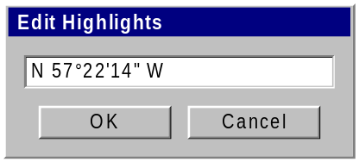
User Interface Figure 9 – Edit Highlights

Delete Highlights
Intention
The Cartographer wants to delete one or more highlights that were used to recognize the image.

Pre-condition
The ‘Image Recognition’ dialog box must be active. One or more highlights must exist for the image.

  - This use case begins when the Cartographer clicks the ‘Delete Highlights’ button from the ‘Image Recognition’ dialog box.
  - The System prompts the user to select the highlights the user wants to delete.
  - The Cartographer draws a crossing window
  - The System deletes any highlights that touch or are contained within the crossing window when the Cartographer lets go of the left mouse button.
  - This use case ends when the Cartographer selects a different tool from the ‘Image Recognition’ dialog box.

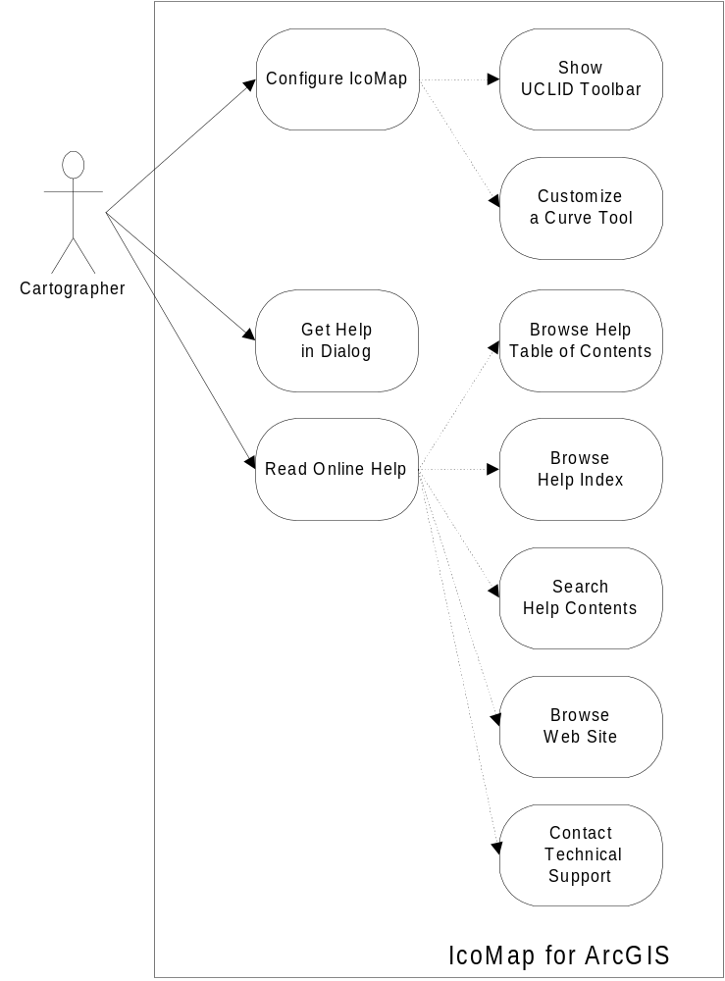

Use Case Diagram 2 – Secondary Use Cases for Cartographer

Get Help in Dialog
Intention
The Cartographer wishes to view information about a particular control (drop-down menu, edit field, checkbox, button, etc.) within a dialog.
Pre-condition
The Cartographer has opened a dialog box containing a ‘? button.

  - This use case begins when the Cartographer clicks on the ‘?’ button in the upper right corner of the dialog (located to the left of the ‘X’ button).
  - The Cartographer clicks on the dialog box control that he wishes to learn more about.
  - The System displays the appropriate help topic onscreen. This is a text-only topic of unlimited size describing a particular control.
  - This use case ends when the Cartographer clicks anywhere on the screen to close the help window or closes the dialog.

Contact Technical Support

Intention
The Cartographer wishes to contact technical support.

  - The Cartographer clicks on the ‘Help’ button in the ‘IcoMap’ dialog box to open the ‘IcoMap Help’ dialog, locates the ‘Getting Technical Support’ topic and clicks the ‘Go to the Technical Support Web Site’ link
  - This use case ends when the System displays the ‘Getting Technical Support’ topic. This help topic lists the information the Cartographer should have ready before contacting Support including Tech Support’s email address and telephone and fax numbers. This help topic also provides a hyperlink to UCLID’s Support Web site.

Browse Web Site
Intention
The Cartographer wishes to get additional help on the IcoMap for ArcGIS Web site.
Notes
If the user goes to the Web site from the Help file, we can display the Web site within the Help window or launch another browser window.

  - The Cartographer clicks on the ‘Help’ button in the ‘IcoMap’ dialog box to open the ‘IcoMap Help’ dialog, locates the ‘Getting Technical Support’ topic and clicks the ‘Go to the Technical Support Web Site’ link
  - This use case ends when the System opens the Cartographer's default browser to the UCLID Tech Support Web site.

Read Online Help
Intention
The Cartographer wishes to read online Help for IcoMap for ArcGIS.
Notes
See User Interface Figure 7.

  - This use case begins when the Cartographer clicks the 'Help' button in the ‘IcoMap’ toolbar.
  - The System displays the ‘IcoMap Help’ dialog with the most recently displayed tab on top.
Variant:
- If this is the first time the System has displayed the ‘IcoMap Help’ dialog, the System displays the ‘Contents’ tab on top opened to the default ‘Welcome’ topic.
  - The Cartographer may browse the table of contents following the Browse Help Table of Contents use case.
  - The Cartographer may browse the index following the Browse Help Index use case
  - The Cartographer may search for a specific topic following the Search Help Contents use case
  - This use case ends when the Cartographer closes the ‘IcoMap Help’ dialog.

Browse Help Table of Contents << Include >>
Intention
The Cartographer wishes to get Help on the IcoMap for ArcGIS product by browsing the Help file Contents.
Notes
See User Interface Figure 10.

  - This use case begins when the Cartographer clicks the ‘Contents’ tab.
  - The Cartographer clicks on the ‘+’ icon to expand a book containing help topic pages or more books. The Cartographer may also click on the ‘-‘ icon to close an open book.
  - The Cartographer may click on a ‘page’ icon to view topics in the ‘Topic’ pane.
  - This use case ends when the Cartographer clicks on another tab or closes the dialog.

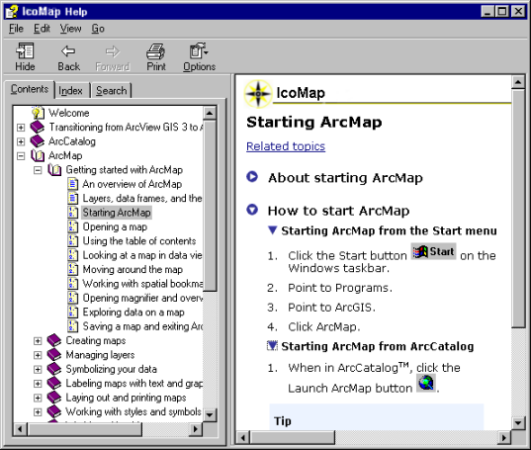

User Interface Figure 10 –Help Contents Dialog

Browse Help Index << Include >>
Intention
The Cartographer wishes to use the Help Index to find application help.

Pre-Condition
The ‘IcoMap Help’ dialog must be displayed.
Notes
See User Interface Figure 11.

  - This use case begins when the Cartographer clicks the ‘Index’ tab.
  - The Help file displays the’ Index’ tab on top..
  - The Cartographer types the keyword(s) into the ‘Type in the keyword to find ’edit field.
  - The System displays the resulting topic in the topic pane. If the same keyword has been indexed to more than one topic, a popup of topic choices appears. In this case, the Cartographer clicks on the relevant topic to view it in the Help window's topic pane.
  - This use case ends when the Cartographer clicks on another tab or closes the dialog.

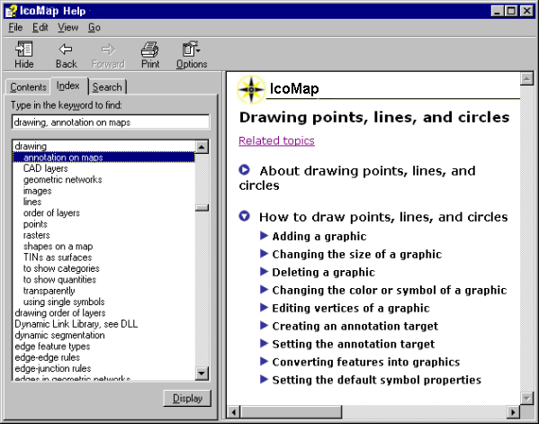

User Interface Figure 11 – Help Index Dialog

Search Help Contents << Include >>

Intention
The Cartographer wishes to find all Help topics containing specific words.

Pre-Condition
The ‘IcoMap Help’ dialog must be displayed.
Notes
See User Interface Figure 12.

  - This use case begins when the Cartographer clicks the ‘Search’ tab.

The System displays the Search tab on top.

The Cartographer types in the ‘Type in the word(s) to search for’ edit field one or more words for which to search.
Variants:

The Cartographer uses wildcard expressions to narrow the search.

The Cartographer combines words using logical expressions (AND, OR, etc.) to narrow the search.

The Cartographer clicks the ‘Search previous results’, ‘Match similar words’ or ‘Search titles only’ check boxes at the bottom of the Search tab to narrow or widen the search.

The Cartographer clicks the 'List Topics' button or presses the 'Enter' key.

The System displays a list of all topics that contain the words for which to search.

The Cartographer double-clicks the title of the desired topic to display the topic.

Variants:

The Cartographer selects the topic and clicks the ‘Display’ button.

This use case ends when the Cartographer clicks on another tab or closes the dialog.

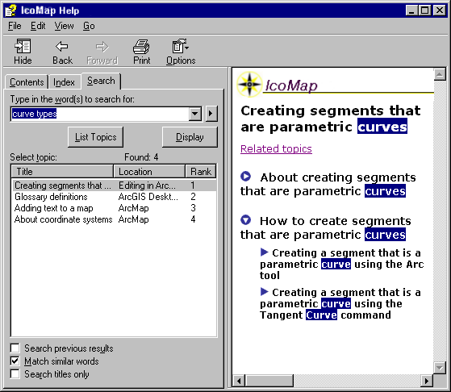

User Interface Figure 12 – Help Search Dialog

Appendix A The ArcGIS Product Line

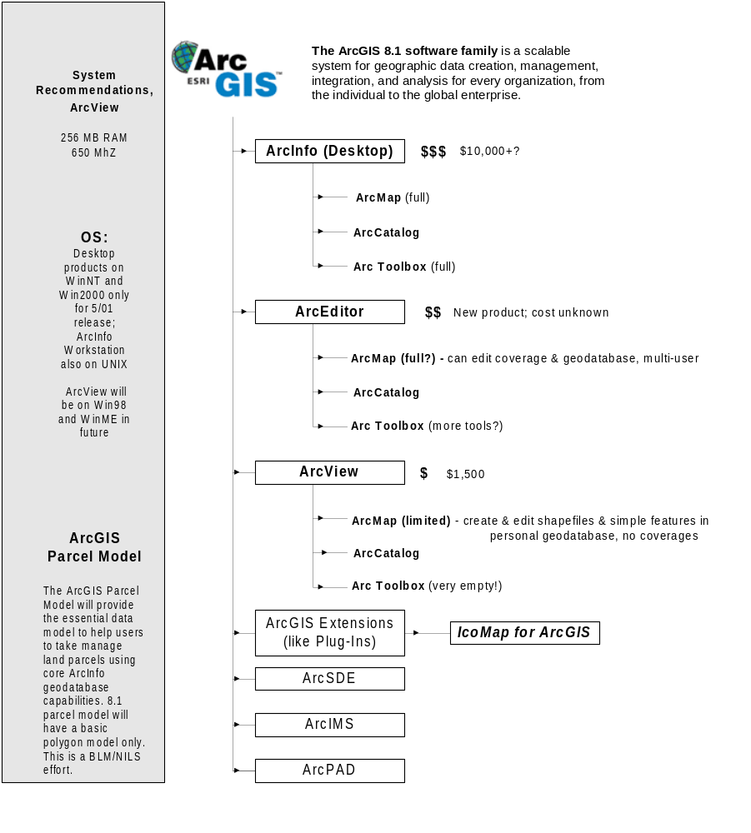

Outstanding Issues:
- What are the exact differences between specific ArcMap releases – especially between ArcView and ArcEditor? ESRI’s marketing literature suggests no difference between ArcEditor and ArcInfo.
- If there are no conversion tools in the Toolbox release of ArcView, where will the IcoMap Batch Recognition tool be located?
- Will our potential customers be running primarily ArcView, ArcEditor, ArcInfo or some combination of the above?

Appendix B User Profiles

Cartographer User Profile

Industries: Tax assessors and other county and local government GIS specialists are likely to be the first target market for this product. State government Transportation (especially Highway) and Natural Resources departments are also strong potential users. To a lesser extent, so are federal agencies such as the BLM and the Census Bureau. This is because ArcView and ArcInfo are widely used in government, and these agencies require a high level of accuracy in parcel conversion. Title and survey professionals are not typically ESRI customers. ESRI penetration in the Utility industry is high, but utilities have not invested in accurate parcel conversion. A survey of GIS users in utilities showed that many electric utilities have already completed conversion, while there appears to be some opportunity for water and wastewater utilities building high-quality GIS. Engineering firms use parcel maps but typically outsource conversion. Conversion houses (3001, SDS, etc.), which are typically ESRI users, may be a good market because this product will fit into their workflow much better than the AutoCAD product did.

User experience: People holding the job title GIS (or Cartographic) Technician are most likely to be performing parcel mapping and conversion work. These individuals are typically male, typically educated beyond H.S. but not necessarily holding a 4-year degree. Others that may be performing mapping as part of their jobs include GIS Specialists (college-educated, technologically-savvy) and Project Managers (college or graduate degreed).

We believe our potential product users are experienced ArcView or ArcInfo users. These individuals should learn IcoMap quickly. However, there is high turnover in the lower-paying GIS/Cartographic Technician positions, especially in government, suggesting that the product be as intuitive as possible.

Appendix C Functional Requirements

1. Filters
1. 1. Distance Interpretation Requirements

    - Distances shall be evaluated using characters detailed in the combination expression: Distance defined in Table 18.
    - The system shall convert the distance the user entered from the unit of the distance they selected to the unit that the drawing is set to.
    - If the distance the user selects does not have a unit associated to it, the system shall assume that the unit is the same as the global unit type defined in the drawing.

1.2. Angle Interpretation Requirements
    - Angles shall be evaluated using characters detailed in the combination expressions: Angle1 and Angle2 defined in Table 19.

1.3. Bearing Interpretation Requirements
    - Bearings shall be evaluated using characters detailed in the combination expressions: Bearing1, Bearing2, Bearing3, Bearing4, Bearing5 and Bearing6 defined in Table 19.

1.4. Value Alternatives Requirements
    - The system shall display the alternatives defined in column 2 of Table 14 in the place of the characters defined in column 1 of Table 14 when they exist in invalid numeric values.
    - The system shall replace invalid degree symbols defined in column 1 of Table 15 with a d.
    - The system shall replace invalid minute symbols defined in column 2 of Table 16 with an m.
    - The system shall replace invalid second symbols defined in column 3 of Table 17 with an s.

2. System Options

2.1. Keyboard Input options
    - The system shall allow the user to customize the NW, NE, SW and SE quadrants each to different alpha numeric characters. The user interface is illustrated in Figure 13.
    - The system shall allow the user to customize the left and right curve directions each to different alpha numeric characters. The user interface is illustrated in Figure 13.
    - The system shall force the user to use a different alpha numeric character for each of the custom options: NW, NE, SW, SE, Left and Right. The user interface is illustrated in Figure 13.
    - The system shall give the user an option to press the ‘Enter’ key to use the last used value of the same type s/he is being prompted for. The user interface is illustrated in Figure 13.

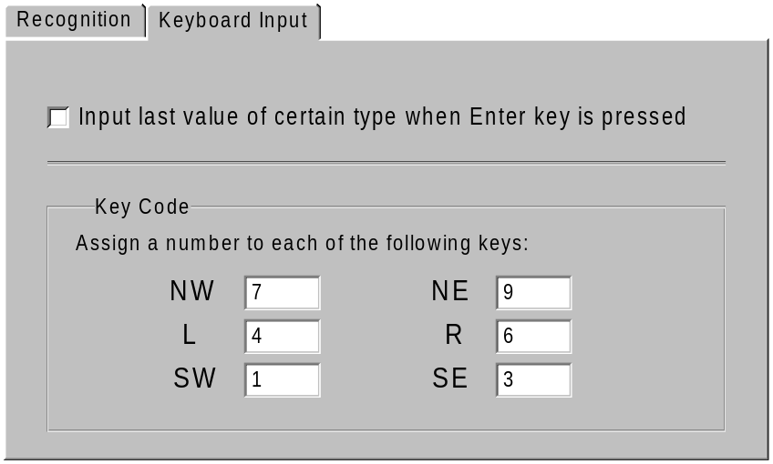
User Interface Figure 13 – Select Features

2.2. Recognition Output
    - If the option is selected, the system shall save the recognized text in the same directory location as the source image. The user interface is illustrated in Figure 14.

2.3. Data Collection
    - When the ‘Enable automatic source document linking…’ option is checked, the system shall automatically add ‘hyperlinks’ of the source files that are being used while using MCR to the features that are being created. The user interface is illustrated in Figure 14.
    - When the system is set to automatically collect source data and the file that the user is creating linework from has not yet been saved, the system shall display a warning message: “You have the option on to automatically collect source data but this file has not been saved. IcoMap will not be able to collect this information until the file has been saved”. [OK] button
    - The system shall only display this warning message once per instance of the MCR Text Viewer.

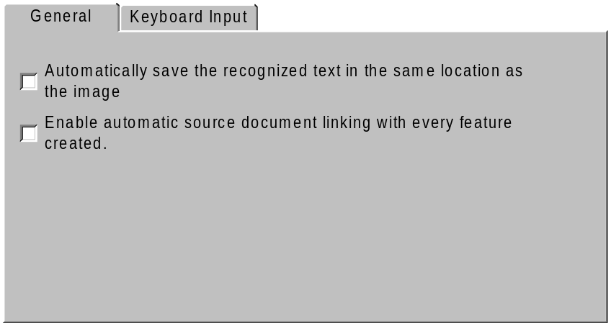
User Interface Figure 14 – Select Features

3. Image Viewer

3.1. Single-page images
    - When the user opens a single-page image, the system shall disable the page-turner controls.

3.2. Multi-page images
    - When the user opens a multi-page image, the system shall enable the page-turner controls.
    - If the image viewer is displaying the first page of a multi-page image, the ‘Backward’ page-turner control will be disabled.
    - If the image viewer is displaying the last page of a multi-page image, the ‘Forward’ page-turner control will be disabled.
    - When the user clicks on the ‘Forward’ page-turner control, the system shall cycle to the next page in the multi-page image.
    - When the user clicks on the ‘Backward’ page-turner control, the system shall cycle to the previous page in the multi-page image.
    - When the user types a page number in the ‘Page Number’ field and presses the ‘Enter’ key, the system shall display that page.
    - If the user types a page number in the ‘Page Number’ field that exceeds the number of pages in the file then presses the ‘Enter’ key, the system shall display the last page in the image.

Table 1: Meter Units
Meters
M
METER
M.
METERS

Table 2: Foot Units
Feet | ASCII Code
F
FT
FOOT
FEET
F.
FT.
‘ | 39
’ | 146
‘ | 145

Table 3: Inch Units
Inches | ASCII Code
IN
INCH
INCHES
IN.
" | 34
“ | 147
” | 148

Table 4: Rod Units
Rods
R
RD
ROD
RODS
R.
RD.

Table 5: Chain Units
Chains
CH
CHAIN
CHAINS
CH.

Table 6: Link Units
Links
L
LINK
LINKS
LKS
L.
LKS.

Table 7: North Direction
North
N
N-
N.
NOR
NOR-
NTH
NTH-
NORTH
NORTH-

Table 8: South Direction
South
S
S-
S.
SOU
SOU-
STH
STH-
SOUTH
SOUTH-

Table 9: Degree Units
Degrees | ASCII Code
D
D.
DEG
DEG.
DEGREE
DEGREES
° | 176
º | 186
%%D
o | 111
-
_
Ø | 248

Table 10: Minute Units
Minutes | ASCII Code
M
M.
MIN
MIN.
MINUTE
MINUTES
‘ | 145
' | 39
’ | 146
-
_

Table 11: Second Units
Seconds | ASCII Code
S
S.
SEC
SEC.
SECOND
SECONDS
“ | 147
” | 148
" | 34
-
_

Table 12: East Direction
East
E
E.
-E
-E.
EST
EST.
-EST
-EST.
EAST
-EAST

Table 13: West Direction
West
W
W.
-W
-W.
WST
WST.
-WST
-WST.
WEST
-WEST

Table 14: Number Alternates
Bad character | Likely replacement
l (lower L) | 1
J | 3
B | 8
Q | 0
O | 0
Z | 2
g | 9
G | 6
I | 1
S | 5
S | 8

Table 15: Degree Alternates
Degrees | ASCII Code
o | 111
’ | 146
” | 148
\
.
?
' | 39
" | 34
*

Table 16: Minute Alternates
Minutes | ASCII Code
` | 96
*
° | 176
º | 186
\
“ | 147
" | 34
” | 148

Table 17: Second Alternates
Seconds | ASCII Code
` | 96
‘ | 145
° | 176
' | 39
*
’ | 146
º | 186

Expression Conventions
| = or
? = optional
{n-m} = repeat at least n times but no more than m times.
{ } = expression
( ) = group
+ = 1-*
* = 0-*
[ ] = character set
Table 18: Value Interpretation Expressions
Expression | Example/Notes
MeterUnits = Column 1 in Table 1
FootUnits = Column 1 in Table 2
InchUnits = Column 1 in Table 3
RodUnits = Column 1 in Table 4
ChainUnits = Column 1 in Table 5
LinkUnits = Column 1 in Table 6
DegreeUnits = Column 1 of Table 9
MinuteUnits = Column 1 of Table 10
SecondUnits = Column 1 of Table 11
NorthUnits = Column 1 of Table 7
SouthUnits = Column 1 of Table 8
EastUnits = Column 1 of Table 12
WestUnits = Column 1 of Table 13
ZeroToFiftyNine = [0-5]? \d
RealNumber = \d* [.]? \d+
StartDirection = {NorthUnits} | {SouthUnits}
EndDirection = {EastUnits} | {WestUnits}
WS = [\t \s]+
FeetUnitDistance = {RealNumber} {WS}? {FootUnits} | 14’ OR 14.50’ OR 0.5’ OR .5’
InchUnitDistance = {RealNumber} {WS}? {InchUnits} | 5” OR 5.2”
EnglishUnitDistance = {FeetUnitDistance} ({WS}? {InchUnitDistance})? | {InchUnitDistance} | 14.50’ OR 14’6” OR 6”
MetricUnitsDistance = {RealNumber} {WS}? {MeterUnit} | 10 m OR 10.54 m
ChainUnitDistance = {RealNumber} {WS}? {ChainUnits} | 5 Chains
RodUnitDistance = {RealNumber} {WS}? {RodUnits} | 2 rods
LinkUnitDistance = {RealNumber} {WS}? {LinkUnits} | 5links
Expression | Example/Notes
YeOldeSurveyDistance = {ChainUnitDistance} | {RodUnitDistance} | {LinkUnitDistance} | {ChainUnitDistance} {WS}? {RodUnitDistance} | {ChainUnitDistance} {WS}? {LinkUnitDistance} | {RodUnitDistance} {WS}? {LinkUnitDistance} | {ChainUnitDistance} {WS}? {RodUnitDistance} {WS}? {LinkUnitDistance} | 12 Chains OR 12 chains 3rods 2 Links OR 12 chains 3 rods OR 12 chains 2 Links OR 4 Chains OR 12 Rods 4Chains 2 Links OR 2 Links OR 12 Rods 4Chains 2 Links
Distance = {RealNumber} | {EnglishUnitDistance} | {MetricUnitsDistance} | {YeOldeSurveyDistance}
Angle = Angle1 | Angle2 | Angle3 | Angle4
Angle1 = 360 {WS}? {DegreeUnits} ({WS}? 0 {1-2} {MinuteUnits})? ({WS}? 0 {1-2} {SecondUnits})? | 360 D 0’ 0” OR 360 D OR 360D15”
Angle2 = (([0-3]? [0-5]?) | ([0-2]? \d?)) \d {WS}? {DegreeUnits} ({WS}? {ZeroToFiftyNine} {MinuteUnits})? ({WS}? {ZeroToFiftyNine} {SecondUnits})? | 9D14’22” OR 100D4’6” OR 359D59’59” OR 300D22’50” OR 290 D 0’ 59” OR 299D44’00” OR 00D00’01” OR 0D0’1”
Angle3 = 360 {WS}? {DegreeUnits}? ({WS}? 00 {MinuteUnits}?)? ({WS}? 00 {SecondUnits}?)? | 360D 00’00” OR 3600000
Angle4 = (([0-2] \d) | ([0-3] [0-5])) \d {WS}? {DegreeUnits}? ({WS}? [0-5] \d {MinuteUnits}?)? ({WS}? [0-5] \d {SecondUnits}?)? | 359 d 59’ 59” OR 3595959 OR 004 D 00’ 12 “ OR 0040012 OR 299D59’59 OR 2995959 OR 019D03’06” 0190306 OR 000D00’01” OR 0000001
Bearing1 = {StartDirection} {WS}? \d 0? ({WS}? {DegreeUnits}) ({WS}? 0 {1-2} {MinuteUnits})? ({WS}? 0 {1-2} {SecondUnits})? {WS}? {EndDirection} | N 90d00’0” W OR N 90d W OR n60d00’e
Bearing2 = {StartDirection} {WS}? \d 0 ({WS}? {DegreeUnits}?)? ({WS}? 00 {WS}? {MinuteUnits}?)? ({WS}? 00 {WS}? {SecondUnits}?) {WS}? {EndDirection} | N 900000 e OR n90e OR N90d00w
Bearing3 = {StartDirection}{WS}? [0-8]? \d {WS}? {DegreeUnits} ({WS}? {ZeroToFiftyNine} {MinuteUnits})? ({WS}? {ZeroToFiftyNine} {SecondUnits})? {WS}? {EndDirection} | S 89d59’59s west OR north 9deg 12Seconds west OR South 04d west
Bearing4 = {StartDirection} {WS}? [0-8] \d ({WS}? {DegreeUnits})? ({WS}? [0-5] \d {MinuteUnits}?)? ({WS}? [0-5] \d {SecondUnits}?)? {WS}? {EndDirection} | N895959w OR n89d12east OR south 011459 w OR S 01d 14’ 29” e
Bearing5 = {StartDirection} | North OR South
Bearing6 = {EndDirection} | East OR West

Table 19: Curve Matrix
 | Tan-in | Tan-out | Radial-in | Radial-out | Chord bearing | Delta | Radius | Arc length | Chord length | Degree of curve | Curve direction | Delta/arc length
1 | X | X |  |  |  |  | X |  |  |  | X
2 | X | X |  |  |  |  |  | X
3 | X | X |  |  |  |  |  |  | X |  | X
4 | X |  |  | X |  |  | X |  |  |  | X
5 | X |  |  | X |  |  |  | X
6 | X |  |  | X |  |  |  |  | X |  | X
7 | X |  |  |  | X |  | X
8 | X |  |  |  | X |  |  | X
9 | X |  |  |  | X |  |  |  | X
10 | X |  |  |  |  | X | X |  |  |  | X
11 | X |  |  |  |  | X |  | X |  |  | X
12 | X |  |  |  |  | X |  |  | X |  | X
13 | X |  |  |  |  |  | X | X |  |  | X
14 | X |  |  |  |  |  | X |  | X |  | X | X
15 | X |  |  |  |  |  |  | X | X |  | X
16 |  | X | X |  |  |  | X |  |  |  | X
17 |  | X | X |  |  |  |  | X
18 |  | X | X |  |  |  |  |  | X |  | X
19 |  | X |  |  | X |  | X
20 |  | X |  |  | X |  |  | X
21 |  | X |  |  | X |  |  |  | X
22 |  | X |  |  |  | X | X |  |  |  | X
23 |  | X |  |  |  | X |  | X |  |  | X
24 |  | X |  |  |  | X |  |  | X |  | X
25 |  | X |  |  |  |  | X | X |  |  | X
26 |  | X |  |  |  |  | X |  | X |  | X | X
27 |  | X |  |  |  |  |  | X | X |  | X
28 |  |  | X | X |  |  | X |  |  |  | X
29 |  |  | X | X |  |  |  | X
30 |  |  | X | X |  |  |  |  | X |  | X
31 |  |  | X |  | X |  | X |  |  |  | X
32 |  |  | X |  | X |  |  | X
33 |  |  | X |  | X |  |  |  | X |  | X
34 |  |  | X |  |  | X | X |  |  |  | X
35 |  |  | X |  |  | X |  | X |  |  | X
36 |  |  | X |  |  | X |  |  | X |  | X
37 |  |  | X |  |  |  | X | X |  |  | X
38 |  |  | X |  |  |  | X |  | X |  | X | X
39 |  |  | X |  |  |  |  | X | X |  | X
40 |  |  |  | X | X |  | X |  |  |  | X
41 |  |  |  | X | X |  |  | X
42 |  |  |  | X | X |  |  |  | X |  | X
43 |  |  |  | X |  | X | X |  |  |  | X
44 |  |  |  | X |  | X |  | X |  |  | X
45 |  |  |  | X |  | X |  |  | X |  | X
46 |  |  |  | X |  |  | X | X |  |  | X
47 |  |  |  | X |  |  | X |  | X |  | X | X
48 |  |  |  | X |  |  |  | X | X |  | X
49 |  |  |  |  | X | X | X |  |  |  | X
 | Tan-in | Tan-out | Radial-in | Radial-out | Chord bearing | Delta | Radius | Arc length | Chord length | Degree of curve |  | Delta/arc length
50 |  |  |  |  | X | X |  | X |  |  | X
51 |  |  |  |  | X | X |  |  | X |  | X
52 |  |  |  |  | X |  | X | X |  |  | X
53 |  |  |  |  | X |  | X |  | X |  | X | X
54 |  |  |  |  | X |  |  | X | X |  | X
55 | X | X |  |  |  |  |  |  |  | X | X
56 | X |  |  | X |  |  |  |  |  | X | X
57 | X |  |  |  | X |  |  |  |  | X
58 | X |  |  |  |  | X |  |  |  | X | X
59 | X |  |  |  |  |  |  | X |  | X | X
60 | X |  |  |  |  |  |  |  | X | X | X | X
61 |  | X | X |  |  |  |  |  |  | X | X
62 |  | X |  |  | X |  |  |  |  | X
63 |  | X |  |  |  | X |  |  |  | X | X
64 |  | X |  |  |  |  |  | X |  | X | X
65 |  | X |  |  |  |  |  |  | X | X | X | X
66 |  |  | X | X |  |  |  |  |  | X | X | X
67 |  |  | X |  | X |  |  |  |  | X | X
68 |  |  | X |  |  | X |  |  |  | X | X
69 |  |  | X |  |  |  |  | X |  | X | X
70 |  |  | X |  |  |  |  |  | X | X | X | X
71 |  |  |  | X | X |  |  |  |  | X | X
72 |  |  |  | X |  | X |  |  |  | X | X
73 |  |  |  | X |  |  |  | X |  | X | X
74 |  |  |  | X |  |  |  |  | X | X | X | X
75 |  |  |  |  | X | X |  |  |  | X | X
76 |  |  |  |  | X |  |  | X |  | X | X
77 |  |  |  |  | X |  |  |  | X | X | X | X

Appendix D Glossary

COGO – COrdinate GeOmetry – the process of keying in accurate land records

Digitization – The process of converting a drawing into a vector CAD drawing by tracing the original
True digitizing – creating lines by picking two points followed by line output and curves by picking three points followed by curve output.
Partial digitizing – Creating lines and curves by digitizing individual pieces of information. EXAMPLE: while drawing a line you have a bearing but not a distance. You enter the value of the bearing and digitize the value of the distance.

CAD – Computer Aided Drafting (and/or Design)

Vector – graphical entities that are created geometrically by specifying start point, end point, radius, etc.

Raster – Graphical entities that are created by filling in pixels

Pixel – A dot!!!

MCR – Mathematical Content Recognition – The process of entering accurate data by selecting pre-existing digital text such as ASCII and Unicode

Clone file – A stripped down copy of an original drawing which can be used to “fudge” into a larger group of files

Delta – Also known as the central angle. It is the angle calculated from the start of a curve to the end of a curve using the center point of the curve as the origin of the angle.

